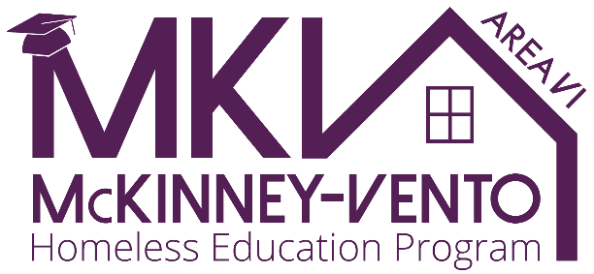

National Homeless Youth Awareness Month
November 2025

Action Toolkit

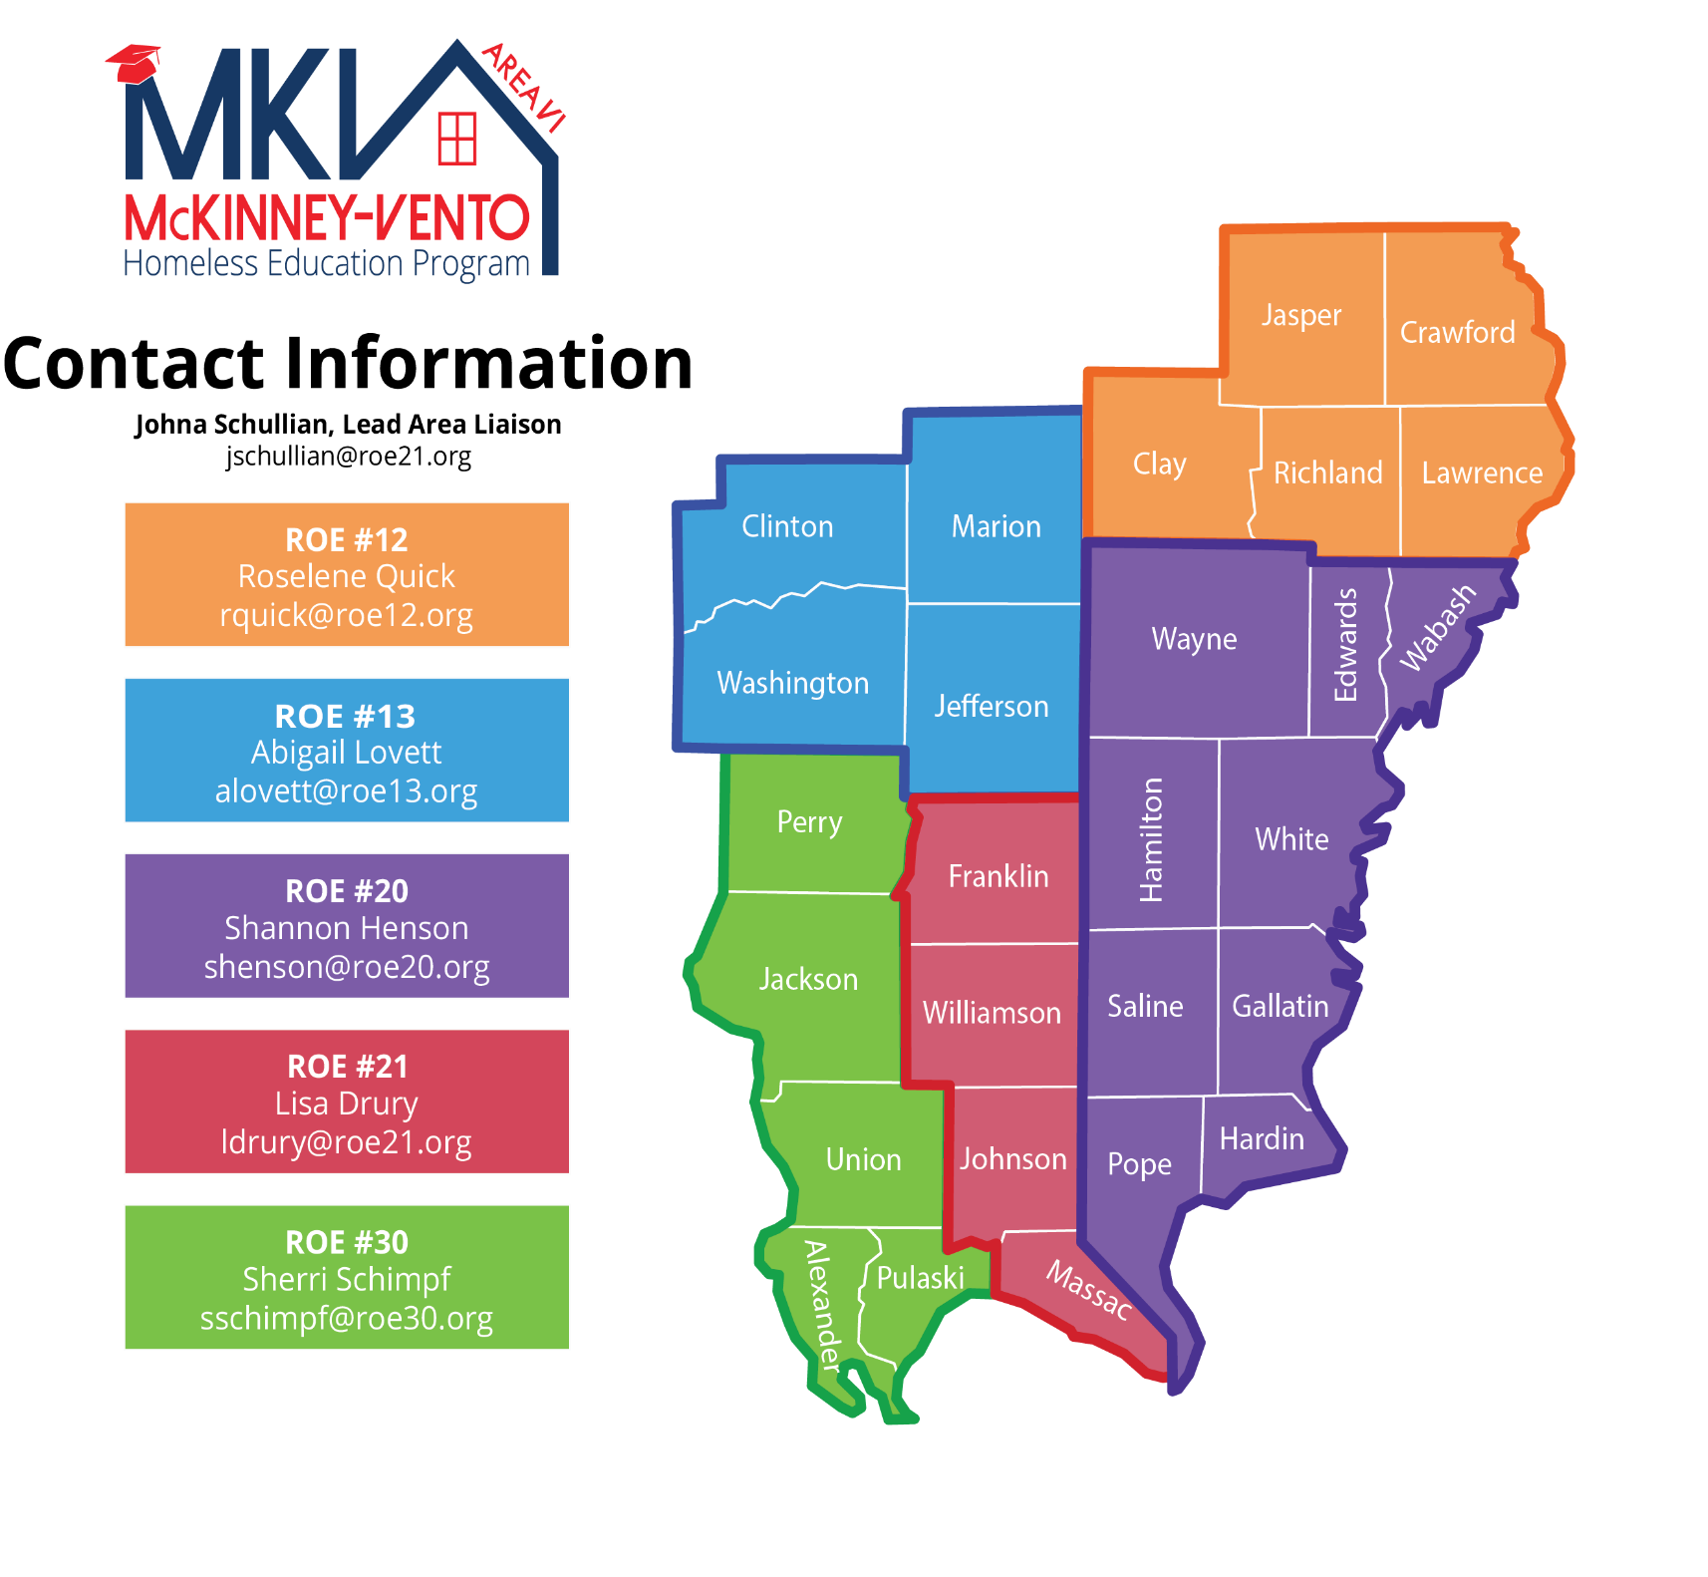


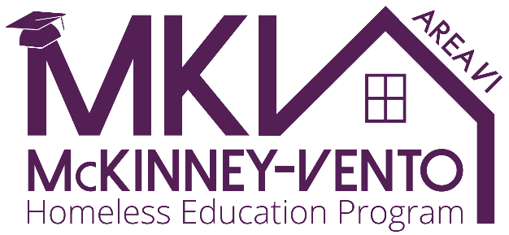

McKinney-Vento Overview

Since 1987, the federal government has worked in partnership with state and local agencies to eliminate barriers to education for children and youth experiencing homelessness through the McKinney-Vento Homeless Education Assistance Improvement Act. This vital legislation ensures that all students, regardless of their housing situation, have the right to enroll, attend, and succeed in school. To support this goal, each school district is required to designate a McKinney-Vento Liaison. These liaisons play a key role in identifying eligible students and addressing obstacles related to enrollment, attendance, transportation, and academic success.
In the 2024–25 school year, across the 27 southernmost counties of Illinois, a significant number of students have been identified as McKinney-Vento eligible—meaning they lack a fixed, regular, or adequate nighttime residence. Of these students, approximately 75% are living in "doubled up" situations, where they share housing due to economic hardship or loss of housing.
To build awareness of youth homelessness, in 2007, Congress declared November as National Homeless Youth Awareness Month (NHYAM). This month serves as a reminder of the urgent need to understand the root causes of youth homelessness, recognize its impact on educational outcomes, and promote collaborative solutions to prevent and address homelessness among children and teens.
This toolkit is designed to:
- Equip educators, community partners, and advocates with foundational knowledge about youth homelessness.
- Highlight local data and challenges unique to Southern Illinois.
- Provide actionable strategies for supporting McKinney-Vento eligible students.
- Promote awareness activities for NHYAM and beyond.
Together, through awareness, compassion, and coordination, we can ensure that every student—regardless of housing status—has access to a stable, supportive, and equitable educational experience.

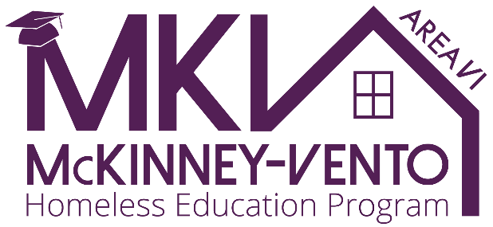

Table of Contents

McKinney-Vento Facts ……………..pg 5

Southern Illinois McKinney-Vento Team ……………..pg 6

Promote awareness ….………….pg 7
- In your school
- In your community
- Paint the town PURPLE

Resources …………….pg 12
- Helpful links

Suggested Activities …….….….pg 12
- Media
- Food/Hygiene Drive

Definition ….………..pg 13

McKinney-Vento Facts
Here is a snapshot of homelessness among school-aged youth in the 27 southernmost counties of Illinois during the 2024–25 school year.
McKinney-Vento Eligible Students: 2024–25
- Total identified MKV students: 6834
- Percentage living in “doubled up” housing: 75%
- Other eligible living situations include:
  - Shelters or transitional housing
  - Hotels/motels due to loss of housing or economic hardship
  - Unsheltered (e.g., cars, parks, abandoned buildings)
  - Inadequate (e.g., lack of utilities, infestations, overcrowding)

Impacts on Education
- Students experiencing homelessness are at an increased risk of:
  - Chronic absenteeism
  - Lower academic achievement
  - Higher dropout rates
- Transportation challenges, lack of basic resources, and emotional stress significantly affect school engagement.
- With every school change, students can lose 4-6 months of academic achievement.

Role of McKinney-Vento Liaisons
- Facilitate immediate enrollment, even without typical documentation
- Ensure transportation to the school of origin
- Connect families with support services (food, shelter, counseling, etc)
Advocate for students’ rights within the school system

Southern Illinois McKinney-Vento team
Meeting the needs of homeless youth requires proactive, compassionate, and coordinated action. Area VI MKV liaisons utilize the TEAM approach, bringing together schools and community organizations to reduce barriers, promote stability, and support academic success.

Team Captains -District Liaison have a big job, and they do it best by including their district team as needed to support MKV students.
1. Identification
- Train all staff (including bus drivers, office staff, teachers, and counselors)
- Review enrollment forms
- Build trust through outreach
2. Enrollment
- Ensure immediate enrollment regardless of missing documents
- Provide transportation to the student’s school of origin to maintain continuity.
- Coordinate with neighboring districts.
3. Attendance
- Offer access to basic needs through in-school pantries or resource closets.
- Provide quiet, consistent spaces for homework.
4. Monitor and Support Academic Success
- Track attendance and academic performance regularly.
- Provide tutoring or mentoring support when needed.

Teammate - Community Agencies; local shelters, food banks, housing agencies.
1. Collaboration with schools to ensure wraparound services are provided.
2. Develop referral protocols so schools can quickly connect students to resources.

Teammate - Community Businesses
1. Help bring awareness throughout the community.
2. Donate to your local schools’ pantries or weekend food programs

Teammate – Public Officials
1. Share the data with your colleagues
2. Advocate on behalf of MKV students

Promote Awareness
National Homeless Youth Awareness Month (NHYAM), recognized every November, is an opportunity for schools and communities to shine a light on the realities faced by children and youth experiencing homelessness—and engage others in prevention and support.
Goals for NHYAM:
- Raise public and school-based awareness of youth homelessness
- Promote understanding of students' rights under the McKinney-Vento Act
- Encourage community involvement and policy change
School Activities
1. Awareness Week Campaign
- Choose a week in November for daily themed activities (e.g., “Wear Purple for Youth,” “Poster Day: What Makes a Home?”)
- Use morning announcements to share facts about youth homelessness
2. Classroom Engagement
- Incorporate age-appropriate lessons or discussions about homelessness, empathy, and resilience
- Host readings or discussions using books that address homelessness
Community Ideas
1. Partner with Local Media
- Submit op-eds or letters to the editor from educators or students about local youth homelessness
- Use school social media channels to post weekly facts or short videos during November
2. Donation and Resource Drives
- Collect hygiene products, winter clothing, or backpacks for MKV students
- Host a “Home Essentials Drive” in partnership with local shelters or housing programs
3. Community Events
- Organize a community night featuring guest speakers, student performances, and information tables from local service providers
- Create a community mural or installation titled “What Every Child Deserves”
Messaging Tips
- Use strength-based language (e.g., “students experiencing homelessness” instead of “homeless kids”)
- Remind the public that most students identified under McKinney-Vento are invisible to the eye—often living doubled up, in motels, or in cars
Promote Awareness
Businesses

To whom it may concern,

As November approaches, we would like to highlight its significance as Homeless Youth Awareness Month. This is an important time to raise awareness about the challenges faced by homeless youth in our community and to promote efforts toward solutions. Our McKinney-Vento Homeless Education program supports the educational needs of these vulnerable students. Students who qualify for McKinney-Vento support are those who lack a fixed, regular, or adequate nighttime residence.
The week of November 3, 2025, we invite the Chamber of Commerce and its members to participate in our "Paint the Town Purple" initiative. This campaign aims to foster awareness and support for homeless youth. Last year, nearly 6900 students in Southern Illinois were identified as McKinney-Vento eligible, highlighting the urgent need for our collective action. We encourage you to pick a day this week and encourage your employees to wear purple on this day to show solidarity and raise awareness.
Additionally, we would greatly appreciate your support in the following ways:
- Billboards: If possible, could you illuminate your billboards purple for the week?
- Yard Signs/Posters: We would be grateful if you could display yard signs or posters at your location to further spread the message. To receive a yard sign compete this Yard Sign reservation form. Feel free to print and use the attached flyer.
Your involvement would not only highlight the importance of this issue but also show our community’s commitment to supporting those in need. Together, we can spark conversations and inspire actions toward addressing youth homelessness.
Thank you for your support in making a difference in the lives of homeless youth in our community.
Warm regards,

Promote Awareness
To Our Esteemed Civic Leaders,
As we approach the month of November, we would like to take this opportunity to recognize its designation as Homeless Youth Awareness Month. This is a vital time to shine a light on the unique challenges faced by youth experiencing homelessness in our communities—and to champion the efforts aimed at creating lasting solutions.
Our McKinney-Vento Homeless Education Program is committed to supporting the educational stability and well-being of students who lack a fixed, regular, and adequate nighttime residence. The need is real and growing—last year alone, 6834 students across Southern Illinois were identified as eligible for services under McKinney-Vento.
To raise awareness and encourage collective action, we are launching our annual “Paint the Town Purple” initiative. We invite you and your offices to join us in this campaign by choosing a day in the week of November 3, 2025, and wearing purple in a visible show of support for homeless youth.
We respectfully request your support in the following ways:
Billboards – If feasible, could you arrange to have local billboards illuminated in purple for the day?
Yard Signs & Posters – Please consider displaying signage at municipal buildings or community gathering spaces. To receive a yard sign compete this Yard Sign reservation form. You may also print and use the attached flyer.
Your leadership plays a critical role in raising awareness and demonstrating the power of a united community response. Together, we can inspire meaningful conversations and foster hope for youth experiencing homelessness.
Thank you for your continued dedication to the well-being of all members of our community.
With appreciation,

Promote Awareness
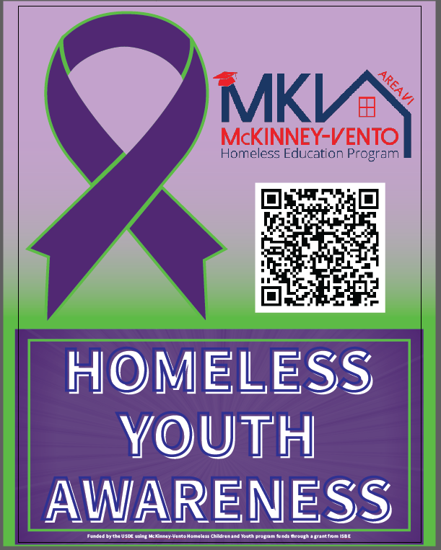

Promote Awareness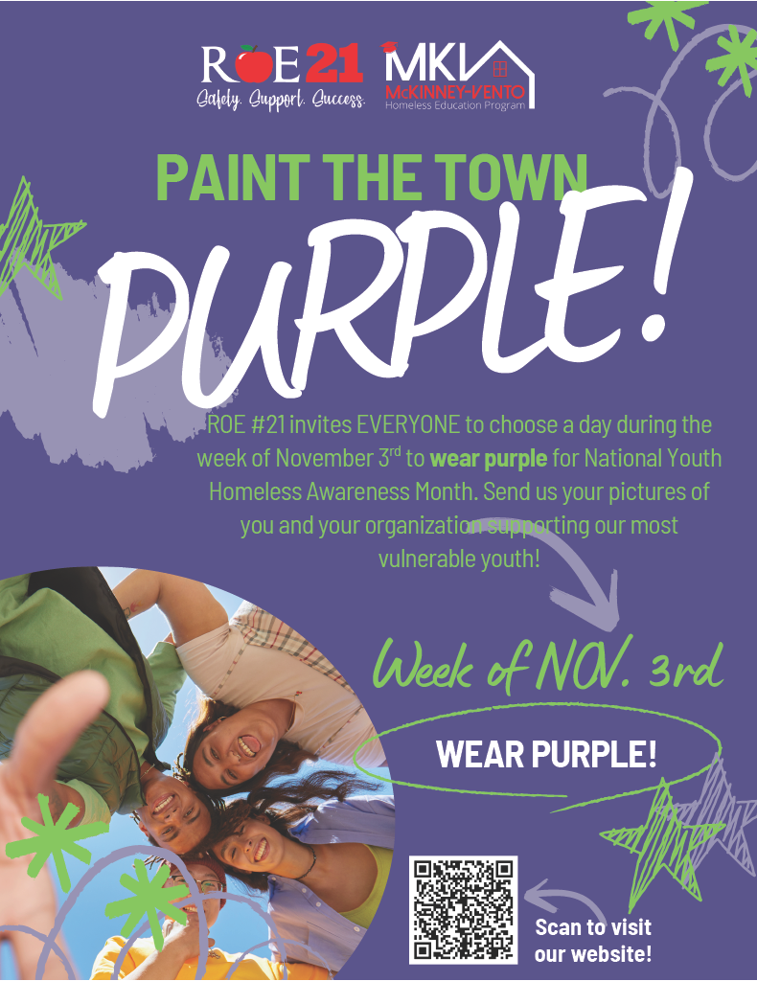

Resources

Helpful Links
- Area VI McKinney-Vento Homeless Program | ROE 21
- School District​ Homeless Liaison Locator
- McKinney-Vento homeless education referral to homeless education liaison
- FindHelpSI.org

Suggested Activities

Media
Videos
- SchoolHouse Connection
A Look at Youth Experiencing Homelessness on Their Own
Books
- Book reading
- Story walk
Paper Things by Jennifer Richard Jacobson
Can’t Get There from Here by Todd Strasser
Shelter by Christie Matheson
The Places We Call Home by Kim Ann
Home by Tonya Lippert
Saturday at the Food Pantry by Diane O’Neill
Dear Librarian by Lydia M. Sigwarth
A Family of Five or Six by Pat Van Doren
A Place of Our Own by Pat Van Doren
Where Can I Build My Volcano by Pat Van Doren
Movies
- Hosted at Civic Centers or school auditoriums
Homeless to Harvard Lifetime Movie
Food/hygiene drives

McKinney-Vento Homeless definition

Subtitle VII-B of the McKinney-Vento Homeless Assistance Act states the following:

The term “homeless children and youths”—
- means individuals who lack a fixed, regular, and adequate nighttime residence (within the meaning of section 103 (a)(1)); and
- includes—
  - children and youths who are sharing the housing of other persons due to loss of housing, economic hardship, or a similar reason; are living in motels, hotels, trailer parks, or camping grounds due to the lack of alternative adequate accommodations; are living in emergency or transitional shelters; or are abandoned in hospitals1;
  - children and youths who have a primary nighttime residence that is a public or private place not designed for or ordinarily used as a regular sleeping accommodation for human beings (within the meaning of section 103 (a)(2)(C));
  - children and youths who are living in cars, parks, public spaces, abandoned buildings, substandard housing, bus or train stations, or similar settings; and
  - migratory children (as such term is defined in section 1309 of the Elementary and Secondary Act of 1965) who qualify as homeless for the purposes of this subtitle because the children are living in circumstances described in clauses
(i) through (iii). (42 U.S.C. § 11434a(2)).

